**Final Year Project Report**

## Smart Home Automation Switches



**Project Advisor:**

**Submitted By:**

**Amaan Majeed**

**Usaid Afzal**

**Hashim Khurshid**

**Ali Zain**

**Session**

**University of Management and Technology**

**C-II Johar Town Lahore Pakistan**

**Acknowledgment**

Hey, we just wanted to take a second to say thank you so much to everyone who has helped us during this times. We want to sincerely thank Ms. Fasiha Ashraf for her excellent leadership and support during the entire process. we couldn't have done it without her persistence, knowledge, and support. Her knowledge and professionalism were crucial in assisting us in successfully completing this assignment.

We are appreciative that we had the chance to learn from Ms. Fasiha, who has been a superb guide. Her extensive knowledge and experience have significantly improved our comprehension of the issue and given us the opportunity to establish a thorough understanding of the project. She has gone above and beyond to assist us in overpowering whatever hindrances we have come across, and for that we are grateful.

We are truly grateful to Ms. Fasiha for her invaluable contributions to this project, and we hope that she will continue to inspire and guide us in the future. We are deeply grateful for her guidance and support, and we hope that our efforts will be a testament to her invaluable contributions.

Online resources like Visual Paradigm, which made our work a lot simpler. We also wanted to express our gratitude to our families and friends for their support, love and affection throughout this journey. Without their support and inspiration, we would not have been able to finish.

Finally, we'd want to express our gratitude to everyone else who helped with this project in some way. We are really appreciative of the chance to participate in this project, and we hope that our efforts will ultimately be beneficial and significant. Thank you, everybody!

**Abstract**

The Home Automation System was created with the motivation to improve the quality of life for disabled individuals who may have difficulty physically accessing outlets and appliances. The system consists of an Arduino-based microcontroller "Node-MCU", and a relay board. The project allows users to remotely control and monitor their appliances from a web browser, smart speaker, or smart device. It supports a range of features, including the ability to create routines, monitor energy usage, integrate with other smart home devices, share control with other users, and use voice control through a smart speaker. The system also offers automation rules, remote access, alerts for certain events, and a customizable interface. In addition, it allows users to set up security measures monitor appliance status, control appliances through a smartwatch, and set up alerts for maintenance tasks. It supports integration with other smart home systems, voice recognition, home security systems, multiple homes, gestures, smart assistants, facial recognition, home entertainment systems, and touchless controls. The Home Automation System aims to smash down barriers between disabled and able-bodied individuals and make them less dependent on others to control their lives. It also serves as a convenient tool for all users, allowing them to easily control appliances from a distance without physically getting up.

# Contents

Smart Home Automation Switches 1

Contents 1

Definitions and Acronyms 3

List of Figures 4

List of Tables 5

1. Introduction 6

1.1 Motivations 6

1.2 Project Overview 6

1.3 Problem Statement 7

1.4 Objectives 7

2. Domain Analysis 8

2.1 Customer 8

2.2 Stakeholders 8

2.3 Affected Groups with social or economic impact 9

2.4 Dependencies/ External Systems 9

3. Requirements analysis 10

3.1 Requirements 10

3.2 List of Actors 12

3.3 List of use cases 12

3.4 System use case diagram 13

3.5 Extended use cases 13

3.6 User interfaces (mock screens) 15

4. Data flow diagram 16

4.1 Data Flow Diagram Level 0 16

4.2 Data Flow Diagram Level 1 16

5. System Design 17

5.1 Class Diagram 17

17

5.2 Sequence Diagrams 18

6. Conclusion 19

7. Future work 20

8. Bibliography 21

8.1 Books 21

8.2 Journals 21

8.3 Articles 21

8.4 Research papers 21

8.5 Other References 21

## Definitions and Acronyms

|  |  |
| --- | --- |
| **Acronym** | **Definition** |
| UMT | University of Management and Technology |
| POS | Point of Sale |
| IOT | Internet Of Things |

Table 1: table of acronyms and definitions

# Introduction

This project was created to allow users to easily and conveniently control their electrical appliances, regardless of their physical location or abilities. The system is built around an Arduino-based microcontroller Node-MCU, a relay switch which can be accessed through a web browser or a virtual assistant like Amazon Alexa.

The system allows users to turn appliances on and off remotely, eliminating the need to physically approach an outlet. This can be especially useful for people who are disabled or have mobility issues, as it enables them to maintain a greater degree of independence and control over their living environment. However, the system is not just limited to disabled individuals - it can be used by anyone looking to simplify their daily tasks and improve their living environment.

In addition to the basic on/off functionality, the system also has the potential to support additional features such as scheduling, energy monitoring, and integration with other smart home devices. The project aims to provide a convenient and accessible solution for controlling appliances, with the ultimate goal of improving the daily lives of all users.

## Motivations

The main motivation for this project was to create a system that would allow users to easily and conveniently control their electrical appliances, regardless of their physical location or abilities. The goal was to break down barriers and make life easier and more independent for people who are disabled or have difficulty accessing outlets and switches due to mobility issues.

In addition to improving the quality of life for disabled individuals, the project also has broader appeal as a smart home solution for anyone looking to simplify their daily tasks and improve their living environment. The ability to remotely turn appliances on and off or set schedules can be especially useful for busy individuals who may not have the time or energy to physically interact with outlets and switches.

Overall, the main motivation for this project was to create a solution that would improve convenience, accessibility, and independence for all users. By leveraging the power of technology and the internet, the project aims to make it easier for people to control their living environments and improve their daily lives.

## Project Overview

This home automation project allows users to remotely control electrical appliances. The system is primarily designed to be used by disabled people who are unable to access outlets physically, but it can also be useful for someone who wants to be able to control their appliances remotely. The project uses an Arduino based microcontroller "Node-MCU", coupled with a "relay board" and a few jumper cables, to allow users to turn appliances on or off by Amazon Alexa or by accessing a web browser on a smartphone, laptop, or tablet. The system can be used with or without internet connectivity, and it is intended to make life easier and more convenient for its users. The system's functions include the ability to turn electrical appliances on or off remotely, and its attributes include being accessible through a variety of devices and being able to be used with or without internet.

## Problem Statement

It can be challenging for people with disabilities or mobility issues to physically access switches in their houses, which can make it challenging for them to operate electrical appliances and lead independent lives. The fact that many conventional home automation systems need users to be physically present near the appliances if they want to operate increases this issue further. Because of this, there is a demand for a home automation system that enables users, irrespective of their mobility or physical ability, to remotely operate their appliances and make their homes more accessible and easy.

## Objectives

* Develops a home automation system that enables users to control devices remotely
* Improves accessibility for people with disabilities or mobility limitations
* Increases independence for users
* Enhances user experience
* Increases safety by allowing for remote control of appliances

# Domain Analysis

## Customer

* Disabled: It would enable them to remotely operate their appliances and make their homes more livable and easier, these clients may be interested in it.
* Homeowner: home automation system enables homeowners to effortlessly operate their appliances from anywhere and can assist to improve the comfort and efficiency of their houses, homeowners may be interested in it.
* Businesses: Companies may be interested in a home automation system since it can increase employee comfort and productivity while also lowering energy expenditures.

## Stakeholders

|  |  |
| --- | --- |
| Stakeholder | Role in System |
| Product development team | This group would be in charge of planning and creating the system, including the necessary software, hardware, and documentation. |
| Quality assurance team | This group would be in charge of testing the system to make sure it complies with all requirements and runs as intended. |
| Project manager | The project manager would be in charge of supervising the system's development and coordinating the work of the many teams and stakeholders. |
| Marketing team | The marketing team would be in charge of generating interest in the product and advertising the system to potential customers. |
| Sales team | The sales team would be in charge of contacting potential partners and distributors as well as selling the system to clients. |
| Customer support staff | The customer support team would be in charge of responding to inquiries from clients, handling any problems or issues, and offering assistance as necessary. |
| Legal team | The legal team would be in charge of reviewing and approving any contracts or agreements connected to the system's development and distribution. |
| Financial team | The financial team would be in charge of overseeing the project's resources and budget, as well as making sure that it continues on track financially. |
| End users | Those who really utilize the system to control their appliances are considered the system's end users. They would be in charge of using the system in accordance with the instructions and recommendations given, as well as offering feedback and suggestions for enhancing the system. |

Table 2: list of stakeholders

## Affected Groups with social or economic impact

* Disables: Improved accessibility and convenience for people with disabilities or mobility limitations
* Homeowners: Enhanced user experience for all users
* Businesses: Increased efficiency and reduced energy costs
* Home automation companies: Increased sales and revenue
* End users: Enhanced user experience for all users and increased safety

## Dependencies/ External Systems

* Microcontroller: The system will likely depend on a microcontroller, such as an Arduino-based Node-MCU, to provide the processing power to control the appliances and create a server on the local network
* Relay board: The system uses a relay board to switch the electrical current magnetically on and off
* Jumper cables: The system will likely use jumper cables to connect the microcontroller and relay board.
* A device with Web-Browser: A device to control the switches on/off
* Wifi service: The system needs wifi router/ Wireless access point regardless of whether the internet comes or not
* Electrical appliances: The system will obviously depend on the electrical appliances that it is designed to control. These could include lights, fans, or any other appliances that are connected to the system.

# Requirements analysis

## Requirements

*Function Categories*

Table

|  |  |
| --- | --- |
| ***Functional Requirements*** | ***The functional requirements for this home automation system are the ability to remotely turn electrical appliances on and off, access the system through a smartphone, laptop, or tablet, and Amazon Alexa for voice control. The system should be able to operate regardless of an internet connection.*** |
| *Non-Functional Requirements* | *Reliability: it should be reliable and consistently perform its functions without failure*  *Usability: the project must be easy to use and understand, with a user-friendly interface*  *Security: The system should be able to protect against unauthorized access*  *Performance: It should be able to perform its functions quickly and efficiently, without undue delays or lag*  *Scalability: The system should be able to handle an increasing workload without loss of performance.*  *Maintainability: The system should be easy to maintain and update, with minimal downtime for repairs or upgrades*  *Compatibility: The system should be compatible with other devices and systems, such as different smartphones just like the new industry standard "Matter"* |
| *Data Requirements* | *Device status data: The system needs stores data about the current status of connected devices, such as whether light is turned on or off.*  *User data: The system may need to store and retrieve data about registered users, including their login credentials and any preferences or settings they have saved.*  *System logs: The system may need to store log data about its operation and any events or errors that occur.*  *Communication data: If the system communicates with other devices or systems, it may need to store and retrieve data about these communications, including the content and timing of any messages sent or received.* |
| *Constraints* | *Network limitations: The system requires an available wifi network to setup. After the setup you can use it regardless of you having an internet connection.*  *Compatibility limitations: The system cannot be run by Google Assistant, it can only be operated by web browser or Amazon Alexa* |
| *External interface requirements* | *Node-MCU, which serves as the brain of the system*  *relay board, which is used to control the electrical appliances by switching the power on and off.*  *A device with a web browser, such as a smartphone, laptop, or tablet*  *An internet connection, mainly for initially setting up the device*  *Electrical Outlets, to bring power to the system* |

## List of Actors

* Product Development Team: Any tools and procedures used by the team to develop and construct the system, plus hardware and software parts.
* Quality Assurance Team: the team's techniques and tools used for testing the home automation system for quality assurance purposes.
* Project Manager: the home automation system and any tools or methods the project manager used to organize, schedule, and keep track of the project's development.
* Marketing Team: strategies and tools used for promoting and advertising the automation system to potential customers.
* Sales Team: methods and tools for pitching the home automation system to potential clients.
* Customer Support Team: the customer's home automation system and tools or procedures used by the staff to assist and support system buyers.
* Legal team: the home automation system and any applicable laws or regulations.
* Financial team: the home automation system and any tools or procedures the team utilised to manage the project's finances, including forecasting and budgeting.
* End users: any devices or appliances that the home automation system is able to manage.

## List of use cases

1. Use the system to remotely turn appliances on or off from a web browser or smart speaker.
2. Set a timer to automatically turn appliances on or off at specific times.
3. Receive notifications when appliances are turned on or off.
4. Set preferences such as the default state of appliances or the type of notifications received.
5. Control multiple appliances at once.
6. Control appliances from multiple devices.
7. Create routines that automatically control multiple appliances at once.
8. Monitor energy usage and receive alerts when usage exceeds a certain threshold.
9. Integrate with other smart home devices such as security cameras or smart locks.
10. Share control of appliances with other users.
11. Set up voice control through a smart speaker.
12. Set up automation rules to control appliances based on certain conditions.
13. Remotely access and control appliances from anywhere with an internet connection.
14. Receive alerts for certain events such as appliance usage or unusual activity.
15. Customize the interface by adding or removing appliances or changing the layout.
16. Set up security measures such as alerts for unusual activity or integration with security cameras.
17. Monitor the status of appliances and view their usage history.
18. Control appliances through a smartwatch.
19. Set up alerts for maintenance tasks such as appliance servicing or replacement.
20. Set up a guest access mode to grant temporary access to appliances.
21. Integrate with other smart home systems.
22. Control appliances through voice recognition.
23. Integrate with home security systems such as alarms or surveillance cameras.
24. Monitor the status of multiple homes.
25. Control appliances through gestures.
26. Integrate with smart assistants such as Amazon Alexa or Google Assistant.
27. Control appliances through facial recognition.
28. Integrate with home entertainment systems such as TVs or sound systems.
29. Integrate with home automation hubs such as SmartThings or Wink.
30. Control appliances through touchless controls such as motion sensors or infrared beams.

## System use case diagram

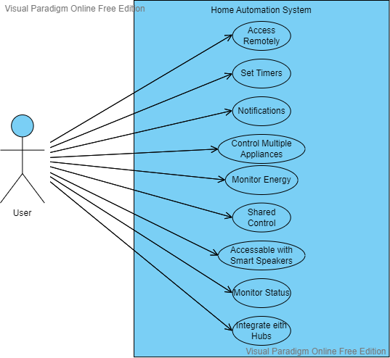

Figure 1: sample use case diagram with explanation

## Extended use cases

Table

|  |  |  |  |  |
| --- | --- | --- | --- | --- |
| **Use Case ID:** | UC - 1 | | | |
| **Use Case Name:** | Interact with Smart Home System | | | |
| **Created By:** |  | | **Last Updated By:** |  |
| **Date Created:** |  | | **Last Revision Date:** |  |
| **Actors:** | | The user communicates with the device | | |
| **Description:** | | The home automation system is a tool that allows users to remotely control and monitor their appliances. It offers a variety of features such as the ability to turn appliances on or off, set timers, receive notifications, set preferences, control multiple appliances at once, and control appliances from multiple devices. The system also supports the creation of routines, energy usage monitoring, integration with other smart home devices, sharing control with other users, and voice control through a smart speaker. It offers automation rules, remote access, alerts for certain events, and a customizable interface. In addition, the system allows users to set up security measures, monitor appliance status, control appliances through a smartwatch, and set up alerts for maintenance tasks. It also supports integration with other smart home systems, voice recognition, home security systems, multiple homes, gestures, smart assistants, facial recognition, home entertainment systems, home automation hubs, and touchless controls. | | |
| **Trigger:** | | Smart Phone, Laptop, Tablet – Web Browser, or a smart speaker like Amazon Alexa | | |
| **Preconditions:** | | Customer has the device setup | | |
| **Post conditions:** | | The Switch turns on/off depending upon the situation | | |
| **Normal Flow:** | | User Toggles a switch on or off from the web browser. | | |
| **Alternative Flows:**  **[Alternative Flow 1 – Not in Network]** | | User Toggles the Switch from a smart speaker like Amazon Alexa | | |
| **Exceptions:** | | Wifi Runs out during setup, for that case, restart the device and strat the setup procedure from the top. | | |
| **Includes:** | | Connection to wifi when setting it all up | | |
| **Frequency of Use:** | | We can expect this to be used upto 60 times a minute. The system keeps on rolling and running, so it can run continuously 24/7 | | |
| **Special Requirements:** | | Wifi required when setting up the device | | |
| **Assumptions:** | | We can assume that the electricity if continuous and the weather is normal, not too hot (60+) and not too cold (-50) | | |
| **Notes and Issues:** | | Each device can make upto 8 switches. If you want more than that, you would have to buy a new device. | | |

## User interfaces (mock screens)

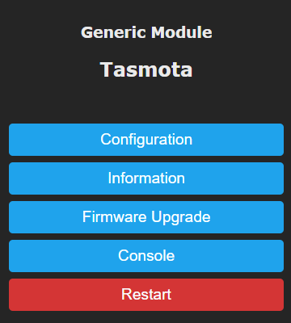

Figure Home page Mockup Screen

# Data flow diagram

## Data Flow Diagram Level 0

Identifies sources and sinks only e.g

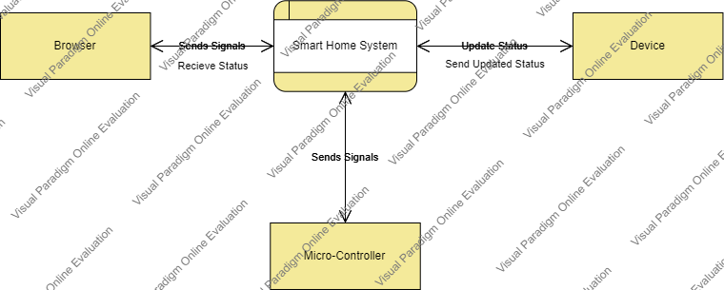

Figure - DFD Level 0

## Data Flow Diagram Level 1

Identifies actual data flows and data storese.g

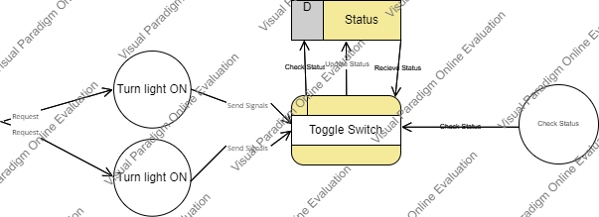

Figure - DFD Level 1

# System Design

Describe the system architecture, or simply provide the architecture diagram. For School system it may include web based front end, webserve , database etc. Don’t worry too much about it just give a simple diagram of a typical web based project.

## Class Diagram

## 

Figure - Class Diagram

## Sequence Diagrams

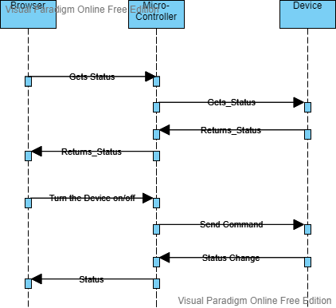

Figure - Sequence Diagram

# Conclusion

In conclusion, the home automation system created for this project is an excellent creation with many applications. Through a web browser or smart speaker, the technology enables users to remotely control electrical equipment from any location in the world. This eliminates the requirement to approach an outlet physically. Users may easily operate their appliances at any time because of the system's accessibility via a range of devices, including smartphones, tablets, computers, and Amazon Alexa.

One of the main advantages of this system is its capacity to reduce the gap between people with disabilities and those without them, ultimately reducing their reliance on outside forces for control of their life. This is an important component of the project since it strives to increase the independence and autonomy of impaired people while also enhancing their quality of life.

The home automation system created in this project can be operated regardless of an internet connection in addition to its many other advantages. Because it enables customers to operate their appliances even when they are not connected to the internet, it is a very versatile and practical solution. When the internet connection is unreliable or inconsistent, as it often is in rural regions and during power outages, this feature is quite helpful.

The system's security is another crucial feature. Your data won't be sent anywhere without your knowledge or agreement because the technology is made to be safe in your immediate area. Any home automation system must take this into account in order to give users confidence that their data is secure and that their privacy is being protected.

Overall, the home automation system is a very practical and innovative product with the potential to have a big impact on its users' lives. It is a valuable addition to any home because it is dependable, simple to use, and offers a wide range of advantages. You can use it with or without an internet connection, and it is a secure option. It is a useful addition to any home because of its many functions and advantages.

# Future work

The creation of new features and functionality for the home automation system is one potential topic for future work. The system might be improved, for instance, to enable more precise management of appliances, such as the capacity to dim lights or change a fan's speed. By doing so, users would have more control over their appliances and be able to modify the setup to suit their own requirements and tastes.

Another potential area for future work is the integration of the system with additional platforms and devices. Currently, the system is accessible through a web browser or smart speaker, such as Amazon Alexa. However, there are many other platforms and devices that could potentially be integrated with the system, such as Apple Home Kit, Google's Assistant - Google Home, smart home hubs, and voice assistants. This would broaden the reach of the system and allow it to be used by an even wider audience.

There might be chances to enhance the system's overall user experience in addition to these functional upgrades. This might entail streamlining the user interface, incorporating more understandable controls, and creating novel user interface interfaces.

Finally, there may be chances to further extend the system's capabilities, for as by supporting new kinds of appliances or creating novel systems for automating and managing the home environment.

The home automation system has a wide range of potential applications, and it is obvious that there is great room for development and innovation in this field. The system is expected to continue to develop and get better over time given the correct resources and assistance, giving people an even more practical and user-friendly approach to controlling their houses.

# Bibliography

Use IEEE or ACM format for citations

## Books

## Journals

## Articles

## Research papers

## Other References

YouTube Videos